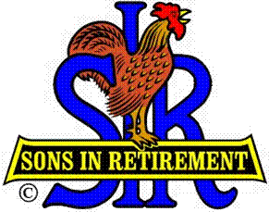

Las Trampas Branch 116

Executive Committee Meeting Agenda

June 18, 2018
9:30 AM
- Call Meeting to Order and confirm we have a quorum.
- Review Agenda/Minutes for Changes/Additions.
- Standing Reports:
Secretary – Fred Schafer: – Approval of April 16, 2018 minutes
Open Discussion
Attendance – Kevin Donahue:
Head count
Missed Luncheons
Open Discussion
Membership – Phil Goff:
New Members to be inducted:
Ed Thomas, Sponsor TBD
Tom O’Brien, Sponsor Jerry Hicks
Andy Myhr, Sponsor Jerry Hicks
Guests Today
Visitors
Open Discussion

Budget – Jim Nickels:
Open Discussion

- Big Sir Report:
- OPEN SEATING and ASSIGNING OF TABLES
- Open Discussion

- Little Sir Report:
- June Speaker:
- Committee Report
- Open Discussion

- Other Reports & Discussion

- Adjourn – 10:15 am

